Willis Allstead

2/5/18

CS 219

HW2

REVIEW QUESTIONS

* 1. Computer organization is a higher-level view of what a computer is organized to be. This means things like how memory is implemented in the system. Computer architecture is more of a document created by which programmers can rely on certain systems in the computer following certain structures. This includes things like interrupts and timers.
  2. Computer structure is just that, the structure of the overall computer. It is how the parts of the computer have been combined to create a single computer. Computer function defines how that certain computer will be used. Uses can range between microcomputers to massively scaled super-computers.
  3. Data processing, data storage, data movement, and control.
  4. The CPU controls the operation of the computer as a whole and processes data. Main memory stores the data you use. I/O is responsible for moving data between the computer and external devices or its external environment. System interconnection provides communication among the previously mentioned components.
  5. The control unit controls the operation of the CPU as a whole. The ALU or arithmetic and logic unit performs the computer’s data processing. The registers provide internal storage for the CPU. The CPU interconnection provides a way of communicating between the previously mentioned components.
  6. A stored program computer stores, and operates with, program instructions in memory.
  7. Moore’s law states that the number of number of transistors in an integrated circuit doubles approximately every two years.
  8. A computer family has similar or identical instruction sets, similar or identical operating systems, with increasing speed, number of IO ports, memory size, and cost with each iteration. Families enable backwards compatibility too.
  9. A microprocessor is called “integrated” because it contains what you would need to build almost any type of device around it.

PROBLEMS

1.1)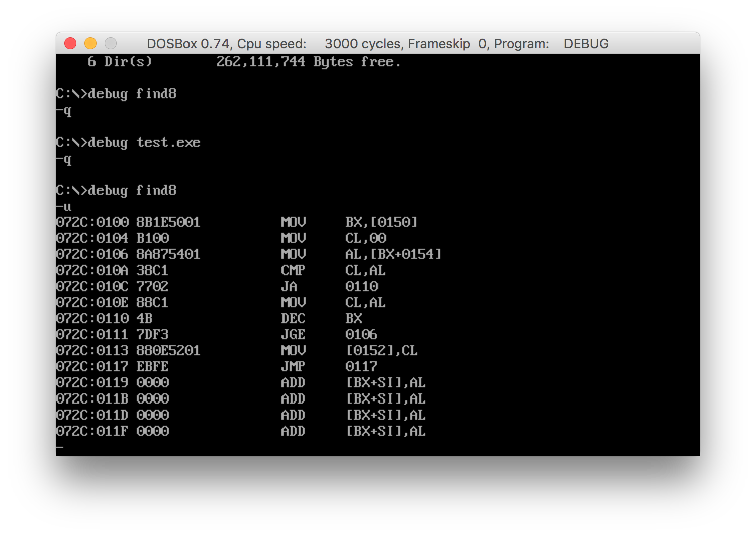

1.2)

a.

location | instruction | comments

0 <> const N (from input)

1 1 const 1

2 2 const 2

3 0 variable Y

4L LOAD M(0) load n into accumulator

4R ADD M(1) add one to accumulator and save it to the accumulator

5L MUL M(0) multiply N times N+1 above, giving N(N+1) in accumulator

5R DIV M(2) divide accumulator by 2 and set to accumulator

6L STORE M(3) save from accumulator to variable Y

6R JUMP M(6,20:39) halting